FACTORIAL WITHOUT RECURSION PROGRAM:

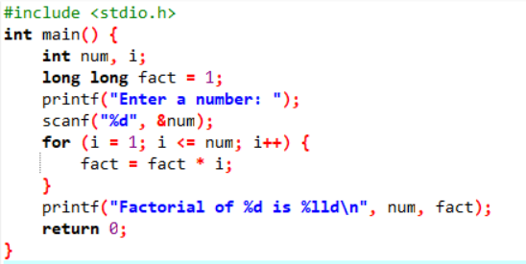

OUTPUT:

